How to filter a report by the Unicode value of a character or string | 
Yoel Kortick
Senior Librarian

ONE
Display the Unicode value of a field so that it can later be filtered. After putting in the filter the display can be removed (if not needed). To display the title for example add the field “title” then do edit formula:

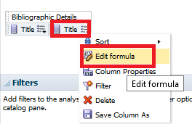

TWO

Instead of
"Bibliographic Details"."Title"
Put
evaluate('ASCIISTR(%1)', "Bibliographic Details"."Title")

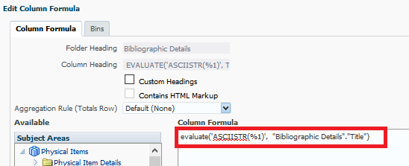

THREE

Above we displayed both the title and the Unicode value of the title. So now we can see them both:

FOUR

The Unicode value of the two dots above the u in ü (known as “COMBINING DIAERESIS”) is U+0308.
See for example https://www.fileformat.info/info/unicode/char/0308/index.htm

Therefore when there is a ü it appears as u\0308

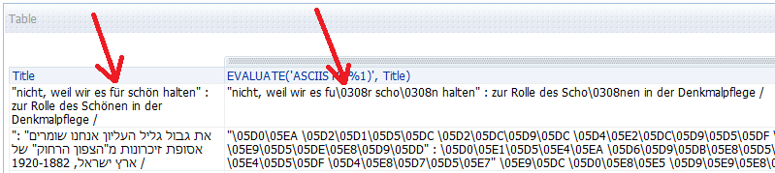

The Unicode value of the word ארץ in Hebrew is a combination of the following three letters:
- א (Alef) which is U+05D0.
  - See http://www.fileformat.info/info/unicode/char/5d0/index.htm
- ר (Resh) which is U+05E8.
  - See https://www.fileformat.info/info/unicode/char/05e8/index.htm
- ץ (Final Tzadi) which is U+05E5.
  - See https://www.fileformat.info/info/unicode/char/05e5/index.htm

Thus the Unicode value of ארץ appears as \05D0\05E8\05E5

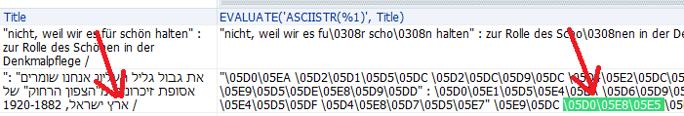

FIVE

Therefore
If we want to search all titles whiuch have a ü then we can filter by the column
evaluate('ASCIISTR(%1)', "Bibliographic Details"."Title")
for
contains any u\0308

If we want to search all titles whiuch have a für then we can filter by the column
evaluate('ASCIISTR(%1)', "Bibliographic Details"."Title")
for
contains any fu\0308r

If we want to search all titles whiuch have a ארץ then we can filter by the column
evaluate('ASCIISTR(%1)', "Bibliographic Details"."Title")
for
contains any \05D0\05E8\05E5

SIX

This will find all titles with für

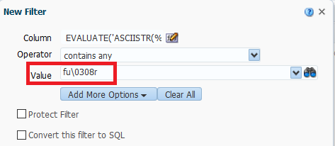

SEVEN

This will find all titles with ארץ

